Keppel, Peter
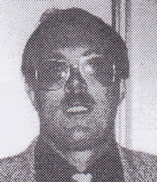
Graduated from Dwellingup Cadet School in late 1960s. Worked in Harvey in 1970s. Promoted to Forester in 1980. District Forester Harvey 1988, promoted to Senior Forester Softwood Logging in Bunbury.
Regional Manager Warren Region 1990s, 2000s.
Axeman in 1970s.
Awarded Australian Fire Service Medal, Australia Day Honours List 2013.

